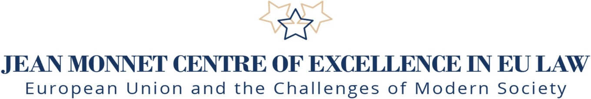

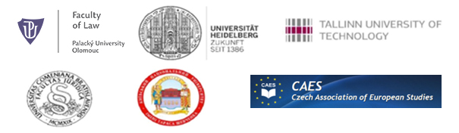

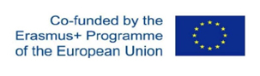

Jean Monnet Scientific Conference
European Union’s Response on the Challenges of Modern Society:
(Legal Issues of Digitalisation, Robotization, Cyber Security and Effective Resilience of Hybrid Threats in the Light of European Law)

26th – 27th April 2023
Venue: Olomouc, Palacky University, Faculty of Law, Rotunda
in person and on-line

An international scientific conference with the involvement of teachers and researchers from Partner universities and with participation of the leading experts from the European institutions and bodies of Czech state administration and national Associations of European studies, will be held in English. This Conference is organised under the Jean Monnet Network bearing the title: „European Union and the Challenges of Modern Society (Legal Issues of Digitalization, Robotization, Cyber Security and Prevention of Hybrid Threats)“, including Palacky University in Olomouc (Czech Republic) as the principal coordinator, the Heidelberg University (Germany), the Tallinn University of Technology (Estonia), the Comenius University in Bratislava (Slovakia), the Taras Shevchenko National University of Kyiv (Ukraine) and in cooperation with the Czech Association of European Studies. The event is held at the Palacky University just in time of celebration of 450 anniversary of its foundation.

Programme of the Conference

First Day - 26th April

Registration of participants: 9:00-10:00

Openning: 10:00-10:30

Welcome addresses:
- Assoc. Prof. et Assoc. Prof. JUDr. Naděžda Šišková, Ph.D., Head of Jean Monnet Centre of Excellence in EU Law, Faculty of Law, Palacky University, President of the Czech Association for European Studies, Coordinator of Jean Monnet Network

- Ph.Dr. Ivan Bartoš, Ph.D., Deputy Prime Minister for Digitalisation and Minister of Regional Development of the Czech Republic

- Prof. MUDr. Martin Procházka, PhD., Rector, Palacky University in Olomouc

- Assoc. Prof. JUDr. Václav Stehlík, LL.M. PhD., Dean of Faculty of Law, Palacky University in Olomouc

Section I. Hybrid Threats and Other Challenges for Modern Society in the Light of Russian Aggression to Ukraine (10:30-11:45)

Chair: Assoc. Prof. et Assoc. Prof. JUDr. Naděžda Šišková, Ph.D., Head of Jean Monnet Centre of Excellence in EU Law, Faculty of Law Palacky University, President of the Czech Association for European Studies, Coordinator of Jean Monnet Network

- PhDr. Petr Kolář, Former Ambassador of the Czech Republic to Russia and former Ambassador of the Czech Republic to the USA: “Was the Russian War against Ukraine Inevitable? Could We Avoid It? What Is the Lesson Learned?”

- Prof. Volodymyr Vasylenko, Kyiv Mohyla University, former Ambassador of the Ukraine to the Great Britain, former member of the International Criminal Court for former Yugoslavia: “Russian Hybrid War Against Ukraine and Model of its International Responsibility for Crime of Aggression

- Prof.Dr.Dr.h.c.mult.Peter-Christian Muller-Graff, Head of the Chair for Economic and European Law, Faculty of Law Heidelberg University, President of the German Association of European Community Studies: “Legal Implications of the Current Question of the European Union´s Strategiovereignty”.

- Mgr.et Mgr. Ondřej Filipec,Ph.D., Ondřej Filipec,Ph.D.,Department of Politics and Social Sciences and Jean Monnet Centre of Excellence in EU Law, Faculty of Law, Palacky University: „Interinstitutional Cooperation Between EU and NATO: Selected Aspects of Cybersecurity and Hybrid Threats Prevention“

Discussion (11:45-12:15)

Lunch (12:15-13:15)

Section II. Digital Technologies and Human Rights. Case-law in the Field of Fundamental Rights in the Light of Modern Technologies. Charter of Fundamental Rights of the EU and the New Rights (13:15-14:30)

Chair: Assoc. Prof. JUDr. Lenka Pítrová, PhD., Department of European Law, Faculty of Law, Charles University in Prague

- JUDr. Emil Ruffer, Ph.D., Director of International Law Department, Ministry of Foreign Affairs of the Czech Republic: “„From CAHAI to CAI and Beyond - The Process of Negotiation the Convention on Artificial Intelligence in the Council of Europe’s Intergovernmental Committee 2019-2023.”

- JUDr. Ondrej Hamulak, Ph.D., Department of International and European Law,Vice-Dean, Faculty of Law Palacky University & Mgr. Lusine Vardanyan, Ph.D. candidate, Palacky University in Olomouc: “The Right to Internet Access: A New Fundamental Right or a New "Platform" for Fundamental Rights?“

- JUDr. Soňa Matochová, Ph.D., Head of Analytic Department, Czech Data Protection Office: “Current Issues of Artificial Intelligence and Human Rights.”

- Mgr. Hovsep Kocharyan, Ph.D. candidate, Faculty of Law Palacky University: "The Key Challenges of the Application of the Right to be Forgotten in Post-GDPR EU Law".

- Mgr. MA. Martin Mach, Ph.D. candidate, Faculty of Law, Palacky University: ”Judgement of the European Court of Justice in case C-460/20 in the Context of Photographs on Social Media“

Discussion (14:30-15:00)

Award Ceremony (15:00-15:30)
Granting of the awards of the Czech Association for European Studies

Coffee break (15:30-16:00)

Section III: Issues of Robotization and its Challenges. AI Liability, Prevention of Risks. Artificial intelligence and Human Rights (16:00-17:00)

Chair: Assoc. Prof. JUDr. Monika Forejtová, PhD., Head of the Department of Constitutional and European Law, Faculty of Law, University of West Bohemia in Pilsen

- Assoc. Prof.JUDr. Marie Patakyová, Ph.D., Department of European Law, Faculty of Law Comenius University in Bratislava: “Algorithmic Collusion and the Proposals de Lege Ferenda“

- Assoc. Prof.JUDr. Jozef Andraško, Ph.D., Vice-Dean and Director of the Institute of Digital Technologies and Intellectual Property, Faculty of Law, Comenius University in Bratislava: “Automated Vehicles and Incident Notification”

- Dr. Agnes Kasper, PhD., Department of Law, Tallinn University of Technology: “Bug off! - The implications of cybersecurity duty of care.“

- Dr. Maria Claudia Solarte Vasquez, Senior lecture, Department of Law, Tallinn University of Technology: “Transaction Design and Human Centred Automation”

- “Mgr. Bohdan Pshenichnyi., Ph.D. student, Institute of International Relations, Taras Shevchenko National University of Kyiv : “Legal Principles of Use of Artificial Intelligence in Public Sphere”

Discussion (17:15-17:45)

Second Day – 27th April

Section IV: Competition Law in the Digital Economy (10:00-11:00)

Chair: Prof.Dr.Dr.h.c.mult.Peter-Christian Muller-Graff, Head of the Chair for Economic and European Law, Faculty of Law Heidelberg University, President of the German Association of European Community Studies

- Mgr. Ing. Kamil Nejezchleb, Ph.D., Vice-Chairman of the Office for the Protection of Competition: „Digital Economy in Practice of the Czech Competition Authority“

- Assoc. Prof. JUDr. Michal Petr, Head of the Department of International and European Law,member of Jean Monnet Centre of Excellence, Palacky University: "Parallel Competences in Digital Markets: Competition Law, Sector Regulation and Ne bis In Idem“

- JUDr. Ondřej Dostal, Head of Competition Compliance Unit, Legal Services Department, CEZ Group: „Digital Economy in Corporate Antitrust Practice“

- Prof. Kseniia Smyrnova, Ph.D., Vice-Rector, Taras Shevchenko National University of Kyiv: “EU –Ukraine Association due to the Candidate Status: Steps Forward Integration to Digital Market“

Discussion (11:00-11:45)

Lunch (11:45-13:00)

Section V: Cyber Security, Cyber Crimes and the Legal Instruments for
Effective Resilience (13:00-14:00)

Chair: Assoc. Prof. JUDr. Blanka Vítová, PhD., Vice-Dean of Faculty of Law, Palacky University in Olomouc, member of Jean Monnet Centre of Excellence

- JUDr. Pavel Telička, Crossroads Consulting, Managing Partner, former Commissioner and former Vice-president of the European Parliament: “Cybersecurity Challenges on the Background of Russian Aggression”

- Assoc. Prof. Lyudmila Falalejeva, Ph.D. and Bohdan Strilets,Ph.D., Koretsky Institute of State and Law of the National Academy of Science of Ukraine: ”Legal Regulation of Cyber Security in Markets in Crypto-Assets: New Challenges for the EU”

- Mgr. Eva Klusová, Transition Media: „Tailoring and Targeting pro-Kremlin Propaganda in the Czech Republic: Target Groups Selection and Ways of Communication Amid Russian Aggression against Ukraine “

- Assoc. Prof. Anna Hurova, Ph.D., Research Fellow at the Littoral, Environmental and Society Department of the Scientific Research National Centre , Paris:” Cyber Security as a Challenge for Future of Space Activity”

Discussion (14:00-14:30)

Coffee break (14:30-15:15)

Section VI: Consumer Protection in on-line World (15:15-16:00)

Chair: Assoc. Prof. JUDr. Michal Petr, Head of the Department of International and European Law, Palacky University, Member of Jean Monnet Centre of Excellence

- Assoc. Prof.JUDr. Blanka Vítová, Vice-Dean, Faculty of Law, Palacky University: „Selected Aspects and Challenges in Consumer Protection in the Digital Era.“
- Dr.iur Rita Simon, LL.M, B.A., researcher, Institute of the State and Law of the Czech Academy of Sciences: „Key Challenges of the Implementation of Directive 2019/770 On Certain Aspects Concerning Contracts for Supply of Digital Content and Digital Services“

- Mgr.Ivan Ivančík, Ph.D., Faculty of Law, Comenius University in Bratislava: “Vigilantibus iura skripta sunt. Consumers and Data Protection in on-line World“

Discussion (16:00-16:30)

Conclusions and Ending of the Conference (16:30-17:00)

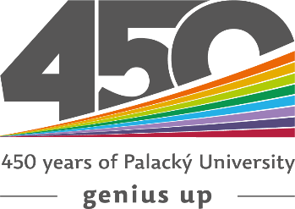

Scientifical and Organization Committee

Assoc. Prof. et Assoc. Prof. JUDr. Naděžda Šišková PhD., Palacky University, Head of the Committee
Prof. Dr. Dr. h.c. mult. Peter-Christian Müller-Graff, PhD., University of Heidelberg
Prof. Tanel Kerikmae, Ph.D. Tallinn University of Technology
Assoc. Prof. Ondrej Blažo, Ph.D.Comenius University in Bratislava
Prof. Dr. Kseniia Smyrnova, PhD., Taras Shevchenko National University of Kyiv
Assoc. Prof. JUDr. Blanka Vítová, PhD., Palacky University
Mgr. et Mgr. Ondřej Filipec, Ph.D, Palacky Univerzity.

The event is organised within the implementation of the Jean Monnet Network „European Union and the Challenges of Modern Society (Legal Issues of Digitalization, Robotization, Cyber Security and Prevention of Hybrid Threats) Project id: 611293-EPP-1-2019-1-CZ-EPPJMO-NETWORK.

